BRAC UNIVERSITY
Department of Computer Science and Engineering

Examination: Final Exam  Duration: 1 Hour 30 Minutes | Semester :Summer 2022  Full Marks: 30
CSE 221: Algorithms
Answer the following questions.
Figures in the right margin indicate marks.

Name: | ID: | Section:

1. | Dhaka, especially your area, is facing an Electricity crisis. Many initiatives including load shedding, reducing office hours, etc have already been taken. The local authority of your area is looking for feasible solutions to reduce the consumption of electricity. One of the members of their advisory committee has suggested that they should reduce the operating costs of road lighting. Till now every road is illuminated all night long. To reduce electricity consumption, they have decided to no longer illuminate every road, but to switch off the road lighting of some roads. To make sure that the inhabitants of your area still feel safe, they want to optimize the lighting in such a way that after darkening some roads at night, there will still be at least one illuminated path from every major point in your area to every other major point.  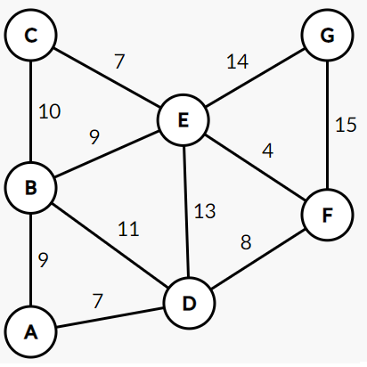  Figure : Graph of your area where the Vertices denote major points and Edges denote electricity consumption in a day.
 | a.  CO3 | Apply a suitable Algorithm to help the authority determine the roads they need to illuminate and the cost which will minimize the electricity consumption. If you need to consider any root vertex for your Algorithm, you can consider 'A' as such.  Solution : Please check the next page.  Solution with Kruskal’s Algorithm  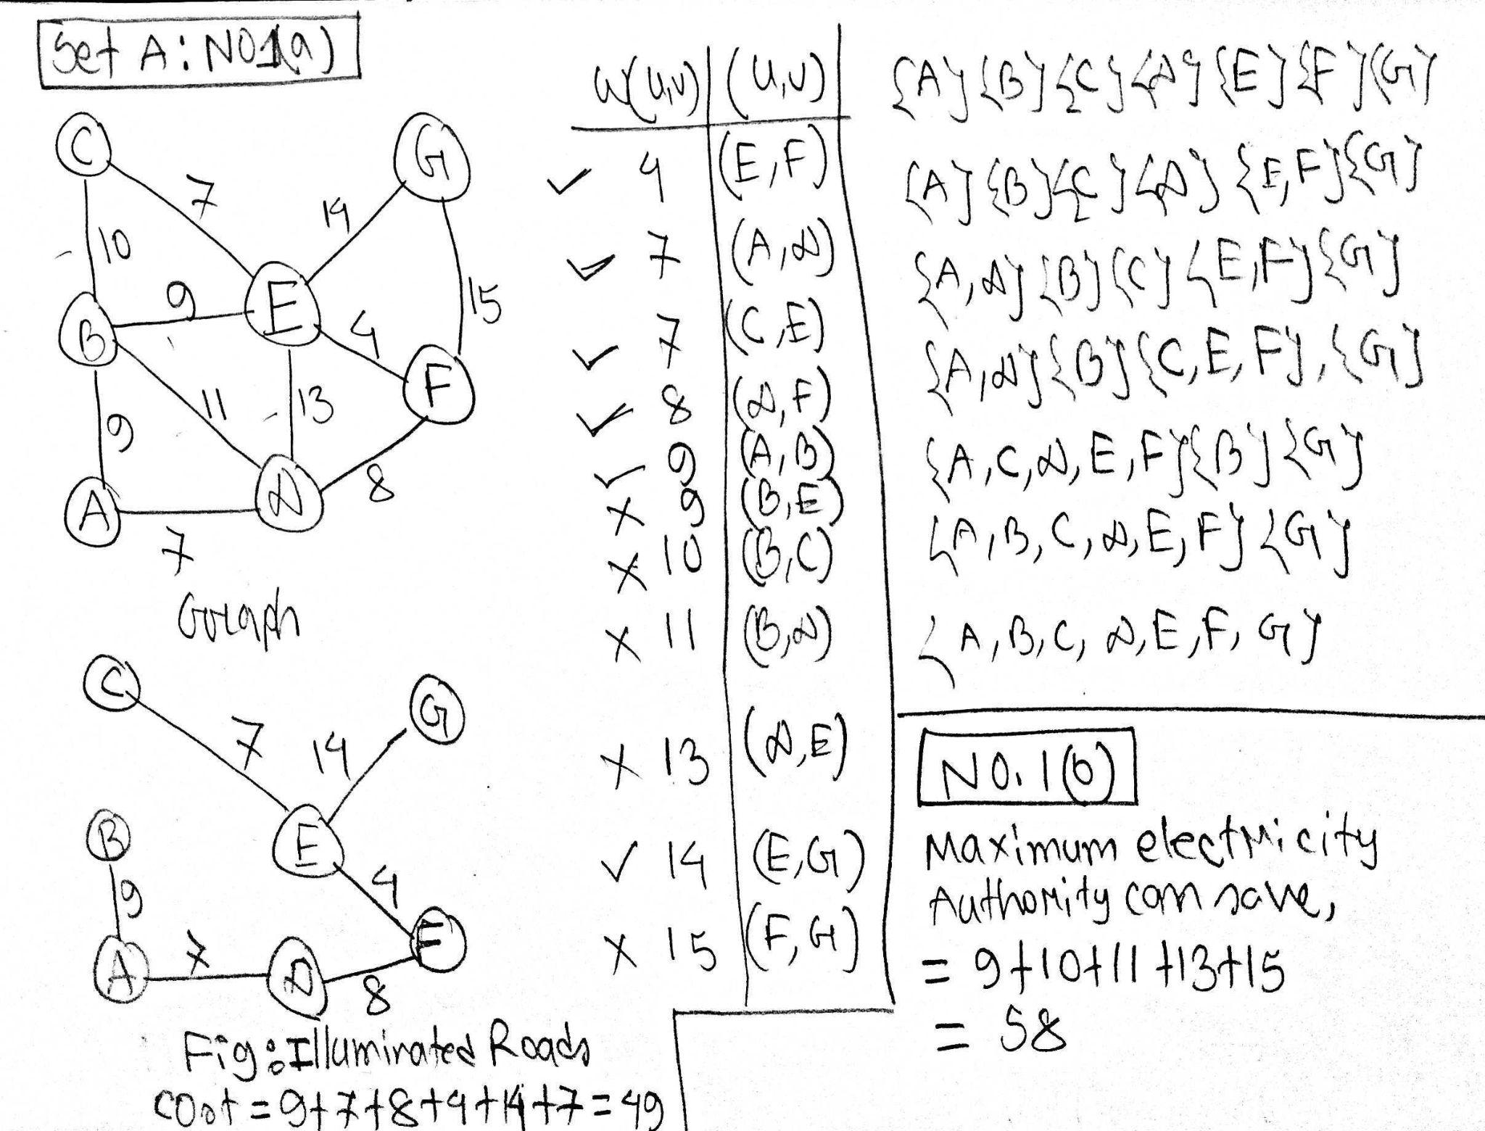  Solution with Prim’s Algorithm  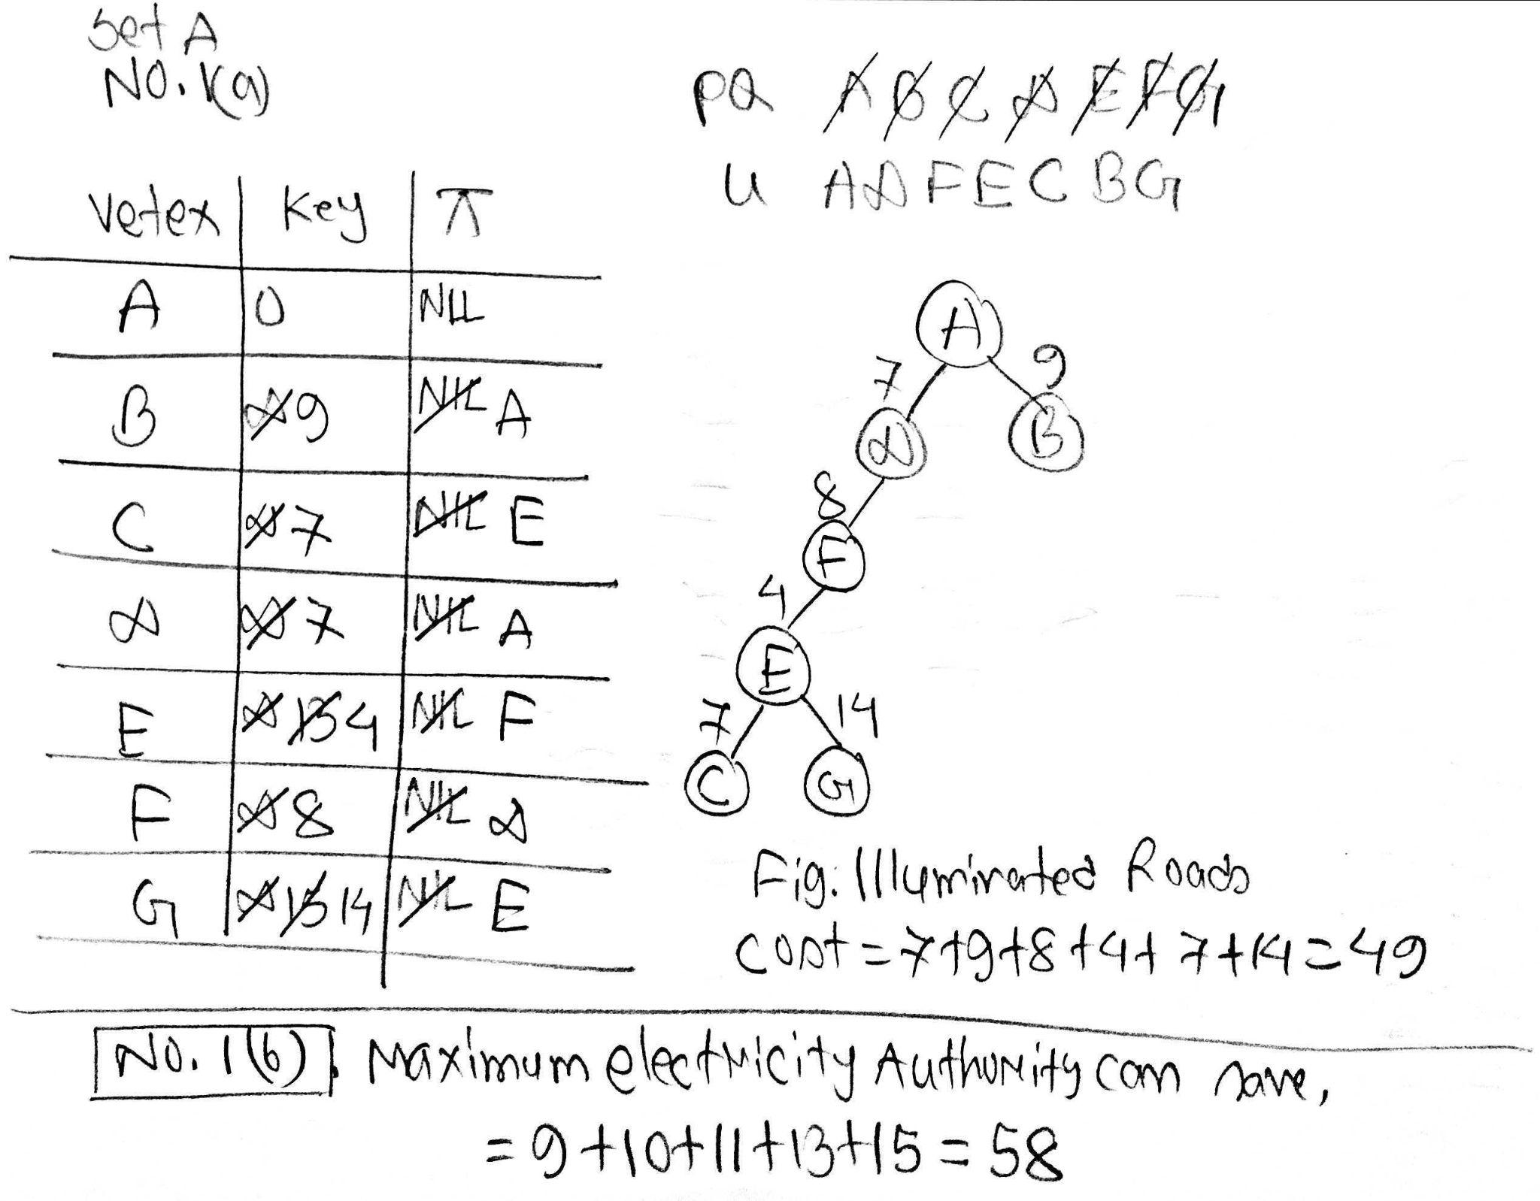 | 6
 | b.  CO5 | Observe the Graph of your area and your provided solution of question 1(a) and determine the maximum electricity of a day the authority can save.  Solution : 9 + 10 + 11 +13 + 15 = 58  (Please check the No 1a solution) | 1
 | c.  CO6 | The United Arab Emirates (UAE), especially Dubai, is hosting the Asia Cup 2022. They too want to minimize the electricity consumption by switching off the lights in some roads leaving exactly one illuminated path from every major point in your area to every other major point. However, to keep the tourists entertained, the Authority of Dubai has taken an opposite approach to yours. They want to illuminate the roads which require the most electricity.  Propose an algorithm to compute the path which fulfills this requirement.  Solution : Please check the next page :  Solution with Kruskal’s Algorithm  MaxST-Kruskal(G,w)  A ← ∅  for each vertex v ∈ V[G]  do make-set(v)  sort the edges of E into non-increasing order by weight w  for each edge (u, v) ∈ E, taken in non-increasing order by weight  do if find-set(u) ≠ find-set(v)  then A ← A ∪ {(u, v)}  union(u, v)  return A  Solution with Prim’s Algorithm  MaxST-Prim(G,w,r)  for each u ∈ V[G]  do key[u] ← -∞  π[u] ← NIL  key[r] ← 0  Q ← V[G]  while Q ≠ ∅  do u ← extract-max(Q)  for each v ∈ Adj[u]  do if v ∈ Q and w(u, v) > key[v]  then π[v] ← u  key[v] ← w(u, v)  For providing a MaxST, one should receive full marks for implementing the Algorithm correctly. Here is a solution with Kruskal’s Algorithm :  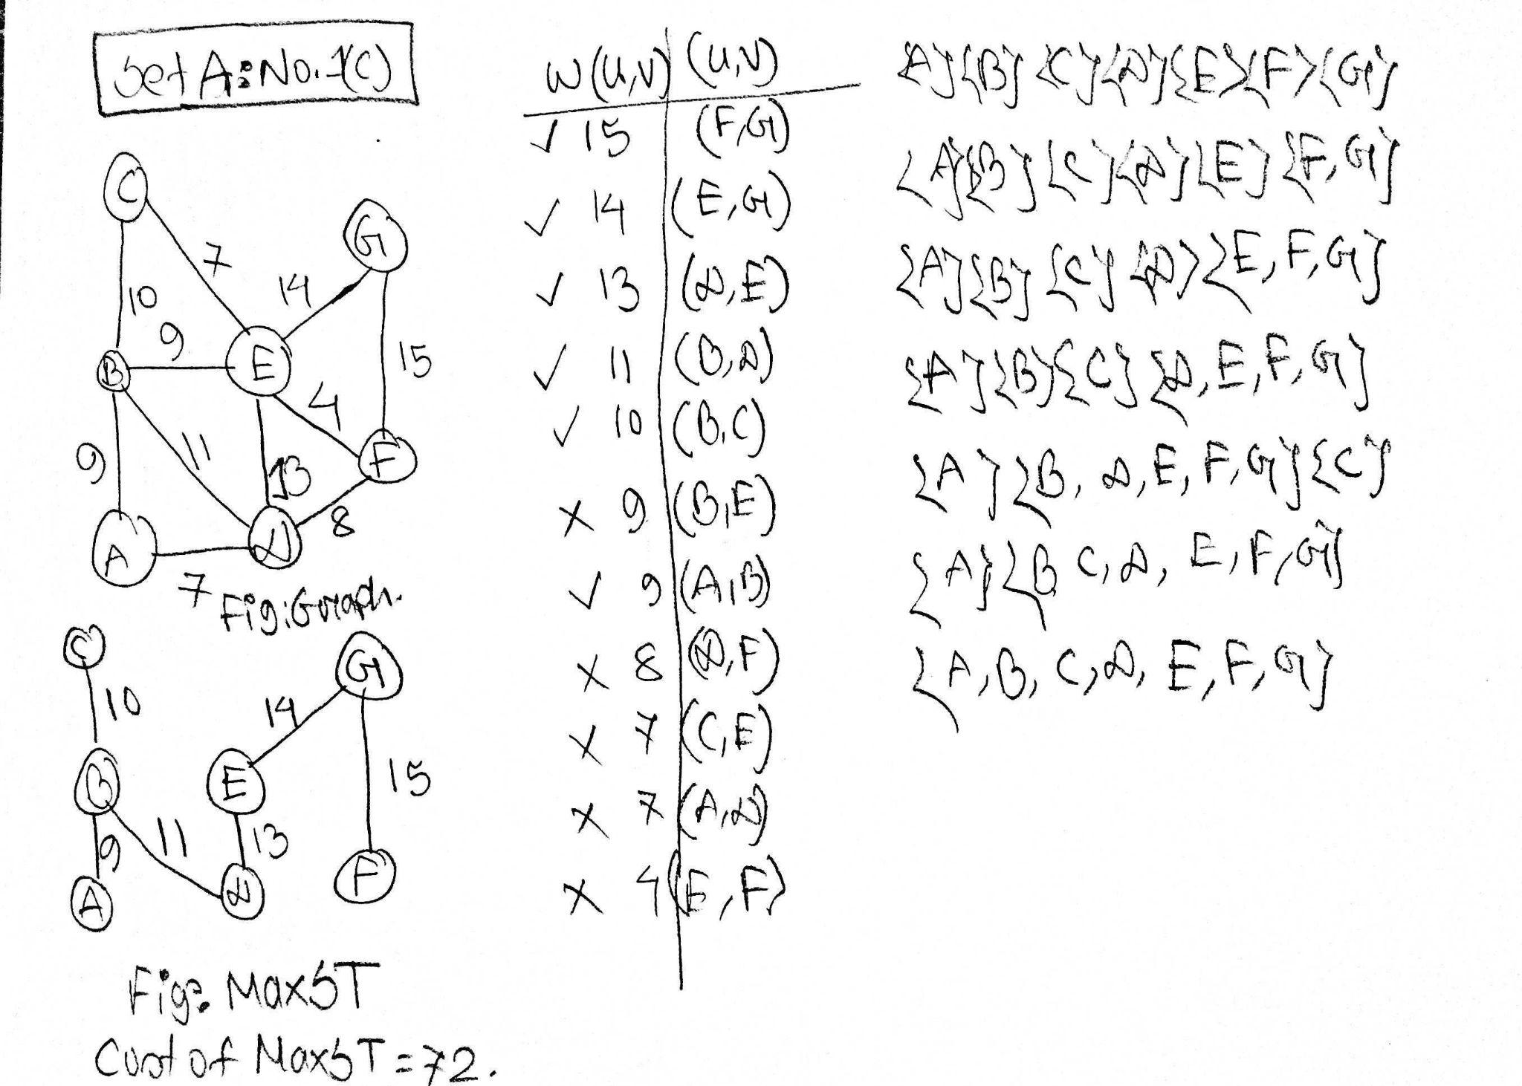 | 3
2. | Alice and Bob both are the peers of a decentralized distributed network. Alice wants to send a message to Bob using the platform but she does not want that any other users of the network would be able to understand the message. That is why she encodes the message using an encoding algorithm which is known to only both of them and sends it to Bob. The message is:  Abaaccdd efkkslasae,eEkls aaad.
 | a.  CO4 | Simulate the Huffman Encoding algorithm to encode the message. Construct Huffman Tree, generate the codeword for each character, show the encoded message and count the total number of bits required to store the message.  Solution:  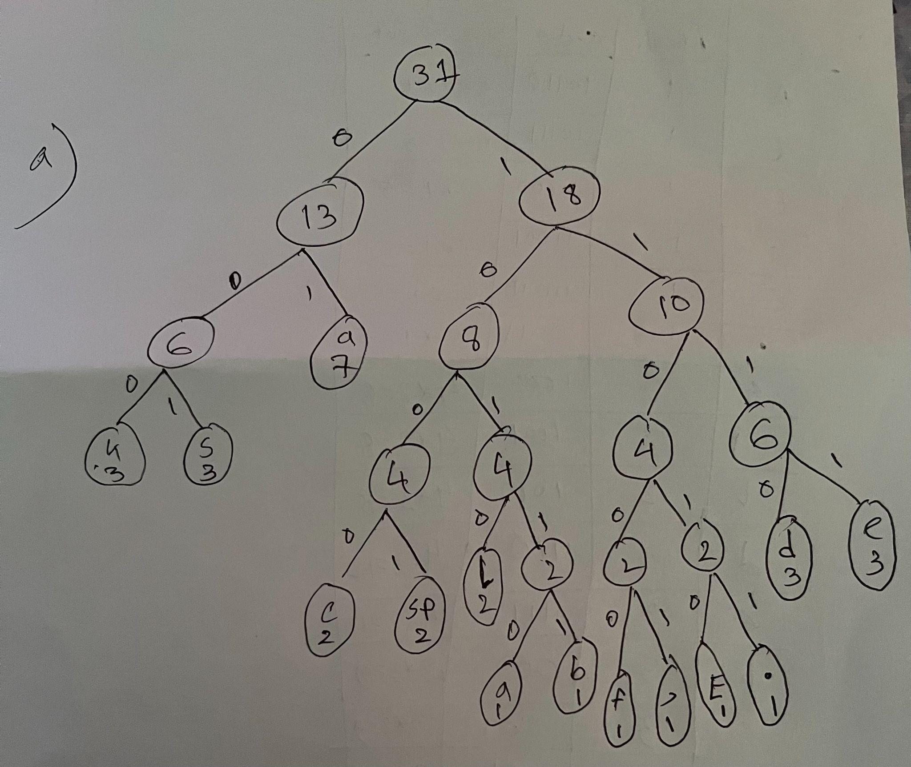  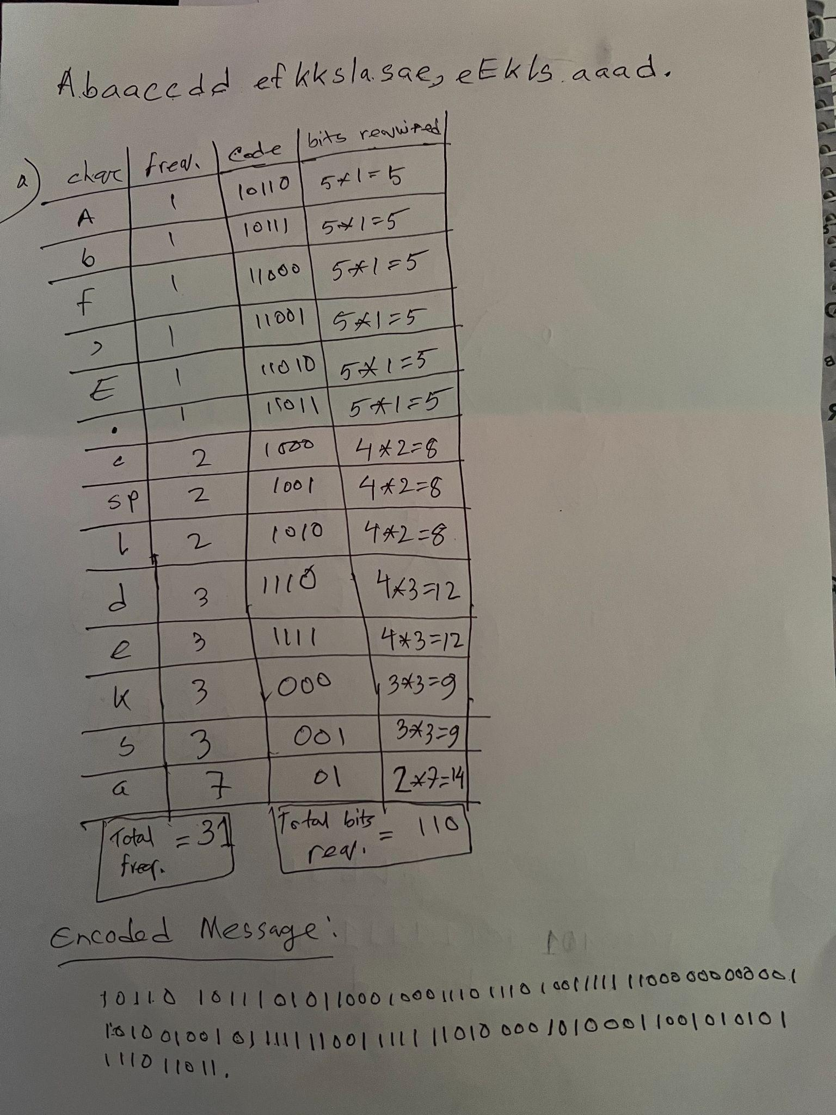 | 7
 | b.  CO5 | Explain the advantage of Huffman Encoding over the ascii codes approach mathematically.  Solution:  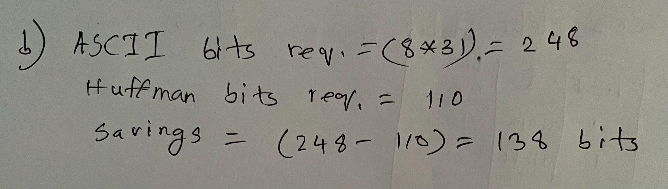 | 1
 | c.  CO4 | After reading the message Bob replied to Alice by sending an encoded message: 100010101011111101010.  Now use the Huffman Tree constructed in question 2(a) to decode the message.  Solution:  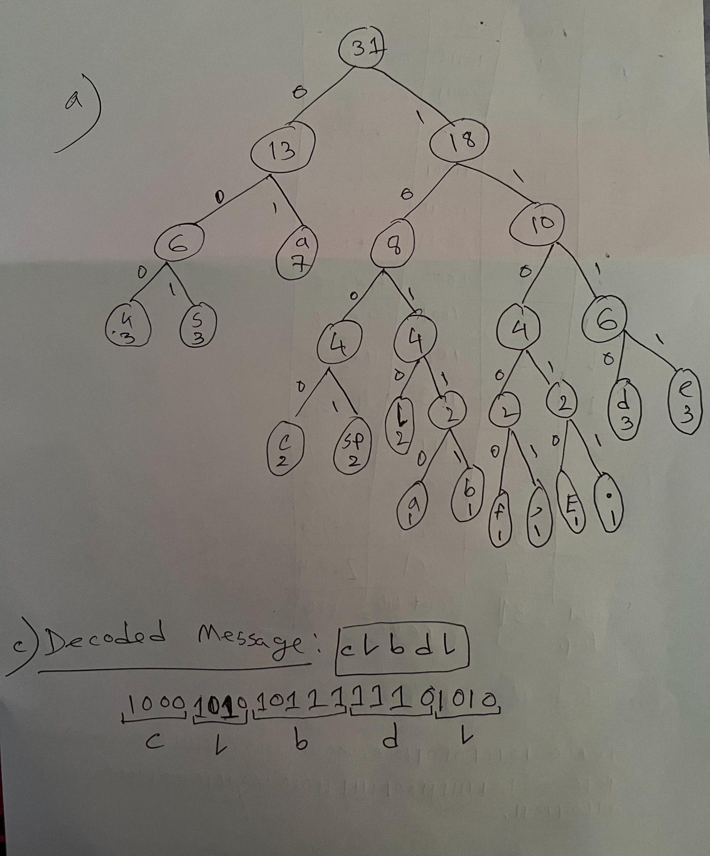 | 2
3. | Today Alice has learned how to find the Longest Common Subsequence (LCS) of two given strings. Now she wants to find the LCS of “axyb” and “abyxb”. After hours of hard work, she has made this LCS table, M.  empty a b y x b  empty 0 0 0 0 0 0  a 0 1 1 1 1 1  x 0 1 1 1 2 2  y 0 1 1 2 2 2  b 0 1 2 2 2 3
 | a.  CO1 | Explain what you understand by the value M[3][4] = 2.  M[3][4] denotes the LCS of “axy” and “abyx”, which is “ay” (or “ax”). | 2
 | b.  CO2 | Find out the LCS String from the table. Show the steps of your work.  There could be multiple solutions.  Solution 1:  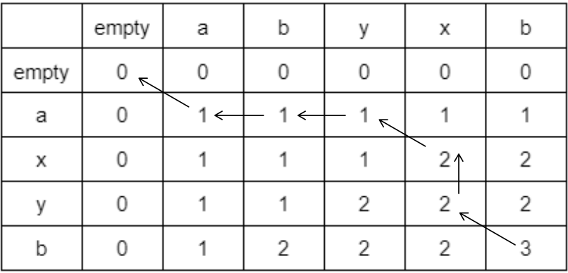  The LCS string of is “axb”  Solution 2:  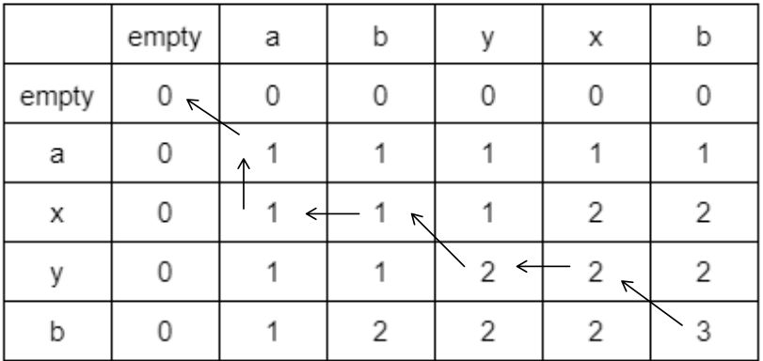  The LCS string is “ayb” | 3
 | c.  CO4 | Determine the maximum profit for the 0-1 Knapsack problem given in the following table using Dynamic Programming. Show the steps with a recursion tree or the memory matrix.  Knapsack Weight: 8 kg  Objects i ii iii iv  Weight (kg) 5 4 6 3  Profit ($) 11 10 12 9  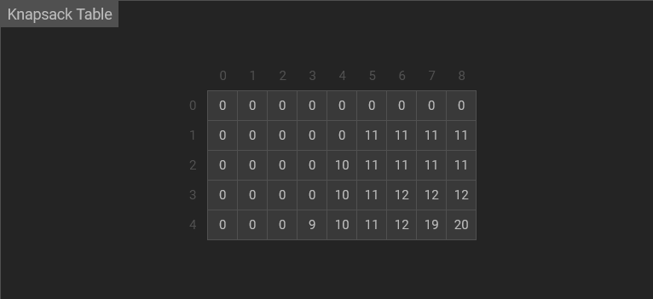 | 5

BRAC UNIVERSITY
Department of Computer Science and Engineering

Examination: Final Exam  Duration: 1 Hour 30 Minutes | Semester :Summer 2022  Full Marks: 30
CSE 221: Algorithms
Answer the following questions.
Figures in the right margin indicate marks.

Name: | ID: | Section:

1. | Dhaka, especially your area, is facing an Electricity crisis. Many initiatives including load shedding, reducing office hours, etc have already been taken. The local authority of your area is looking for feasible solutions to reduce the consumption of electricity. One of the members of their advisory committee has suggested that they should reduce the operating costs of road lighting. Till now every road is illuminated all night long. To reduce electricity consumption, they have decided to no longer illuminate every road, but to switch off the road lighting of some roads. To make sure that the inhabitants of your area still feel safe, they want to optimize the lighting in such a way that after darkening some roads at night, there will still be at least one illuminated path from every major point in your area to every other major point.  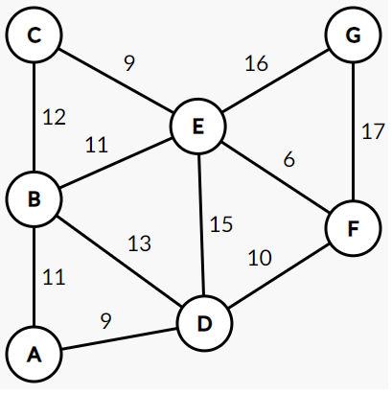  Figure : Graph of your area where the Vertices denote major points and Edges denote electricity consumption in a day.
 | a.  CO3 | Apply a suitable Algorithm to help the authority determine the roads they need to illuminate and the cost which will minimize the electricity consumption. If you need to consider any root vertex for your Algorithm, you can consider 'A' as such.  Solution : Please check the next page.  Solution with Kruskal’s Algorithm  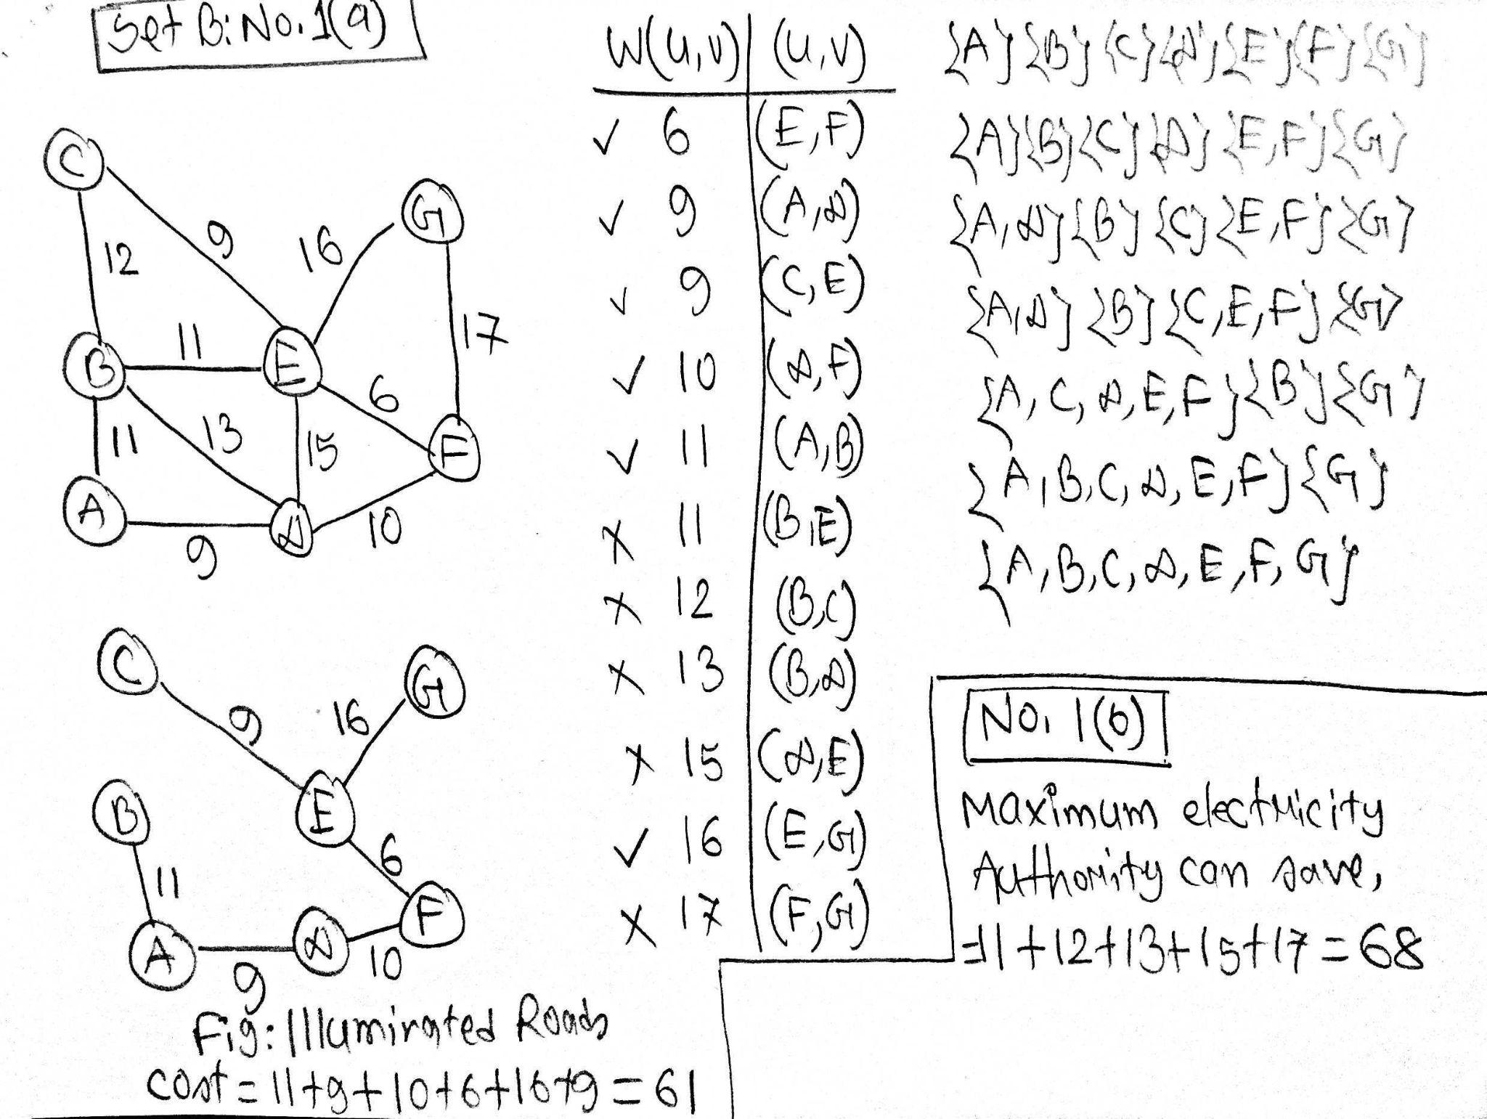  Solution with Prim's Algorithm  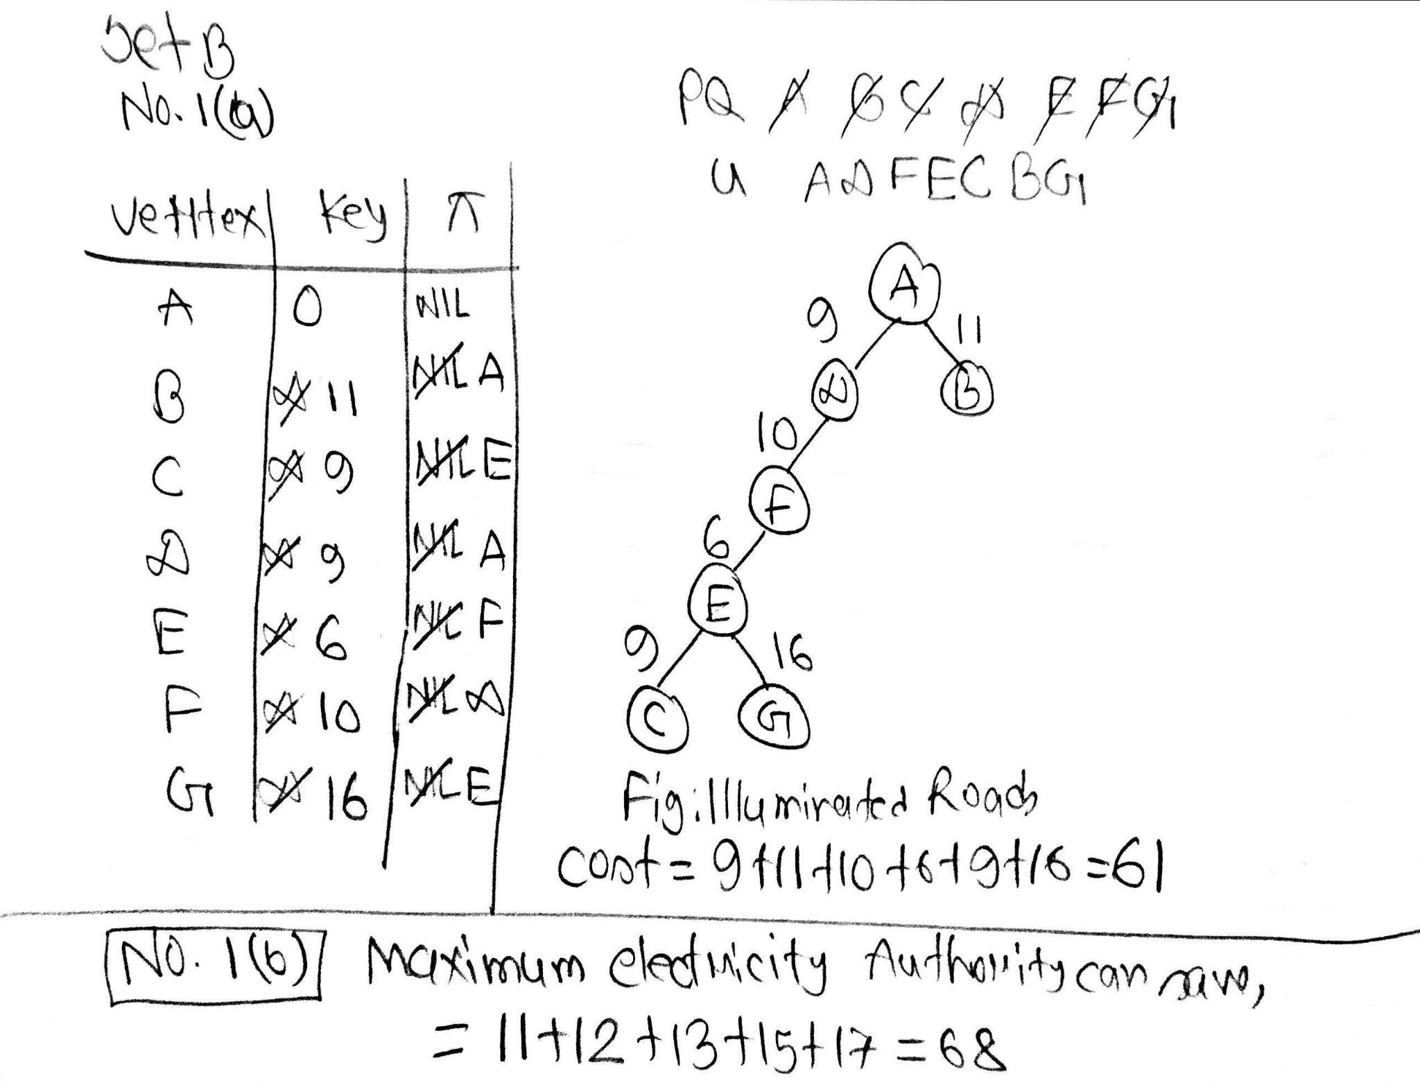 | 6
 | b.  CO5 | Observe the Graph of your area and your provided solution of question 1(a) and determine the maximum electricity of a day the authority can save.  Solution : 11 + 12 + 13 + 15 + 17 = 68  (Please check the No 1a solution) | 1
 | c.  CO6 | The United Arab Emirates (UAE), especially Dubai, is hosting the Asia Cup 2022. They too want to minimize the electricity consumption by switching off the lights in some roads leaving exactly one illuminated path from every major point in your area to every other major point. However, to keep the tourists entertained, the Authority of Dubai has taken an opposite approach to yours. They want to illuminate the roads which require the most electricity.  Propose an algorithm to compute the path which fulfills this requirement.  Solution : Please check the next page :  Solution with Kruskal’s Algorithm  MaxST-Kruskal(G,w)  A ← ∅  for each vertex v ∈ V[G]  do make-set(v)  sort the edges of E into non-increasing order by weight w  for each edge (u, v) ∈ E, taken in non-increasing order by weight  do if find-set(u) ≠ find-set(v)  then A ← A ∪ {(u, v)}  union(u, v)  return A  Solution with Prim’s Algorithm  MaxST-Prim(G,w,r)  for each u ∈ V[G]  do key[u] ← -∞  π[u] ← NIL  key[r] ← 0  Q ← V[G]  while Q ≠ ∅  do u ← extract-max(Q)  for each v ∈ Adj[u]  do if v ∈ Q and w(u, v) > key[v]  then π[v] ← u  key[v] ← w(u, v)  For providing a MaxST, one should receive full marks for implementing the Algorithm correctly. Here is a solution with Kruskal’s Algorithm :  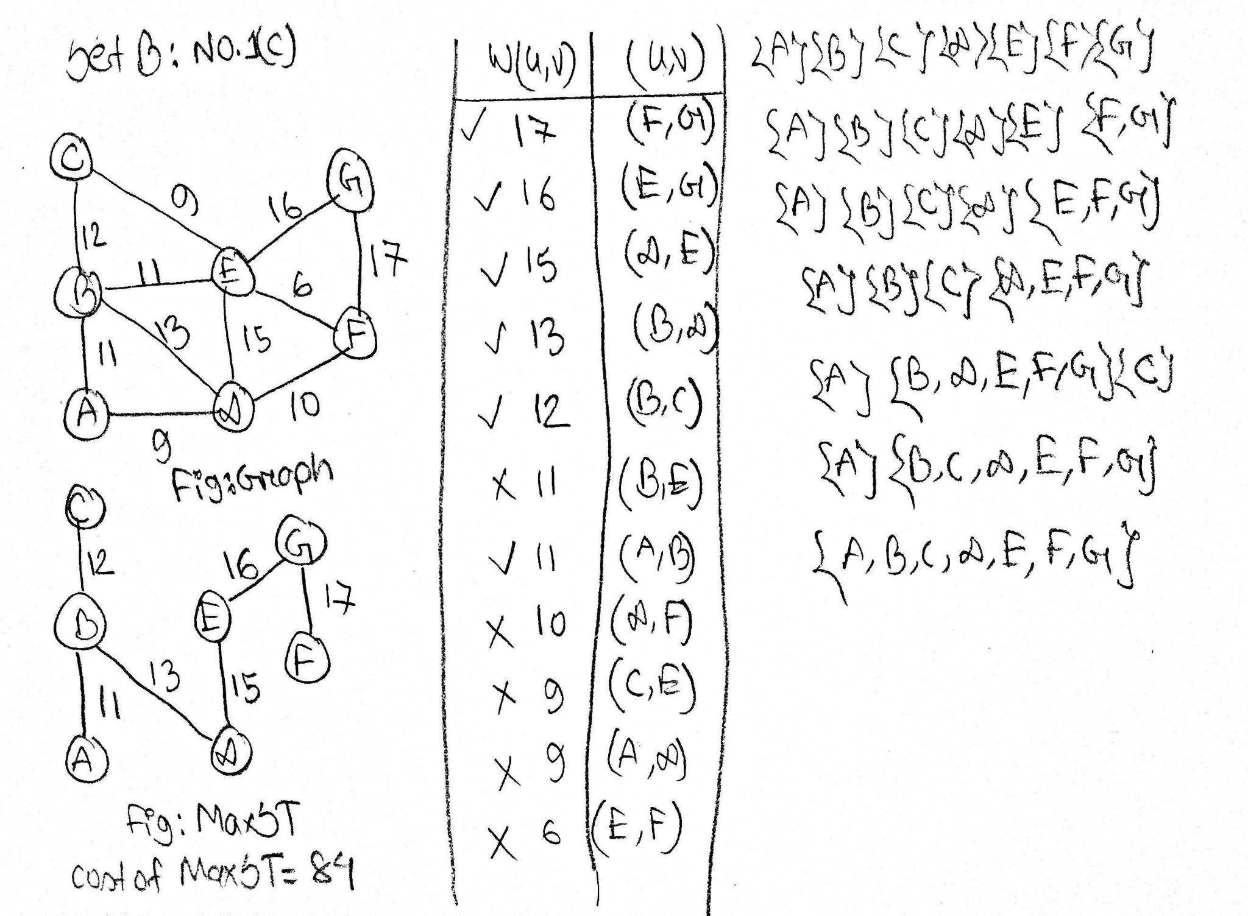 | 3
2. | Alice and Bob both are the peers of a decentralized distributed network. Alice wants to send a message to Bob using the platform but she does not want that any other users of the network would be able to understand the message. That is why she encodes the message using an encoding algorithm which is known to only both of them and sends it to Bob. The message is:  Saaees eklassddd,Aeeesss lkes.
 | a.  CO4 | Simulate the Huffman Encoding algorithm to encode the message. Construct Huffman Tree, generate the codeword for each character, show the encoded message and count the total number of bits required to store the message.  Solution:  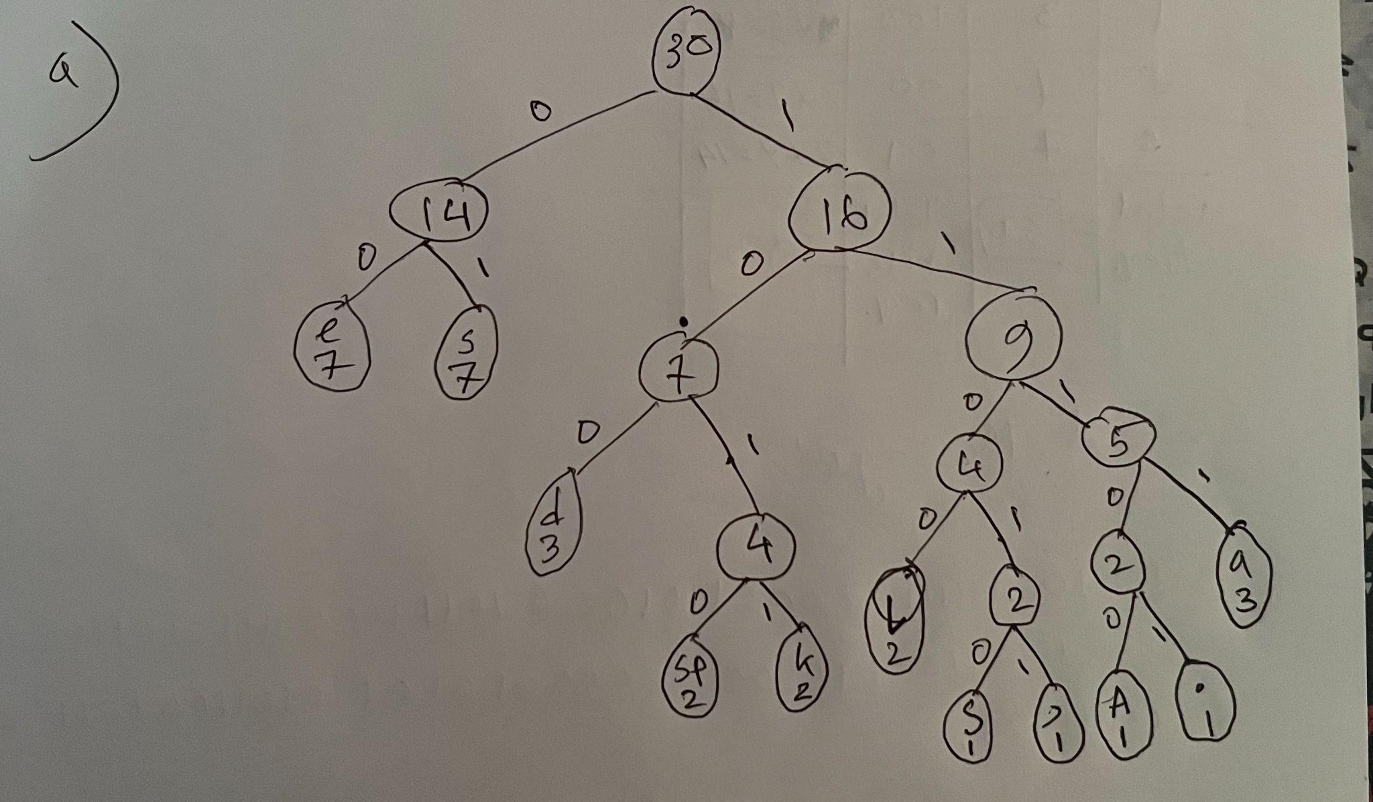  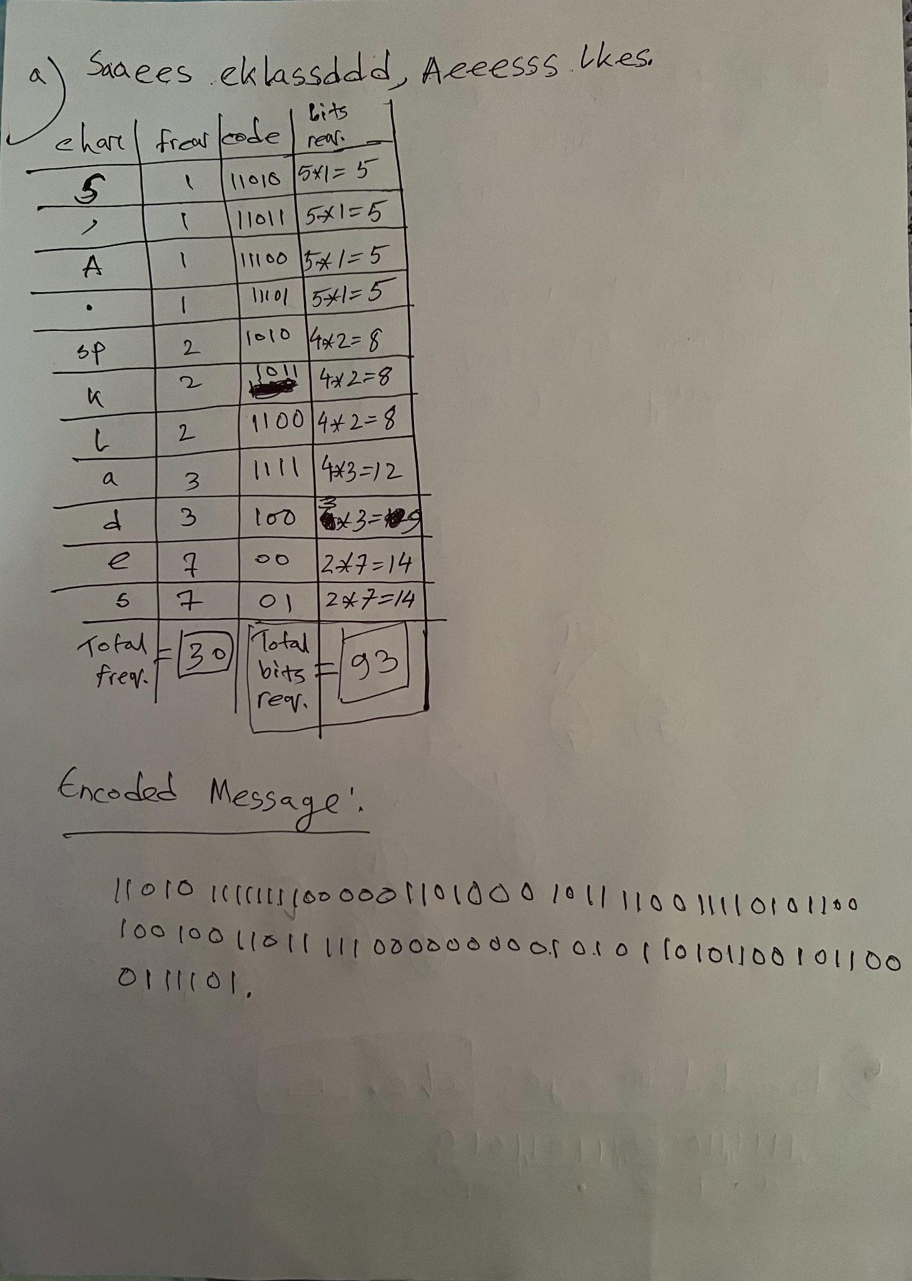 | 7
 | b.  CO5 | Explain the advantage of Huffman Encoding over the ascii codes approach mathematically.  Solution:  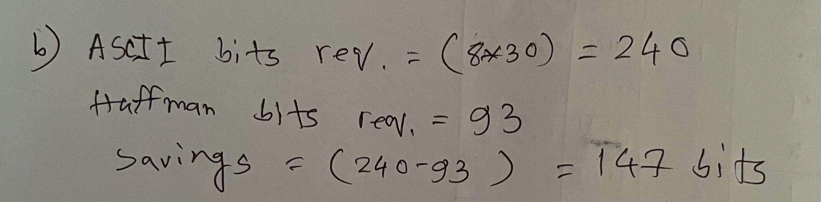 | 1
 | c.  CO4 | After reading the message Bob replied to Alice by sending an encoded message: 1111110000111011010.  Now use the Huffman Tree constructed in question 2(a) to decode the message.  Solution:  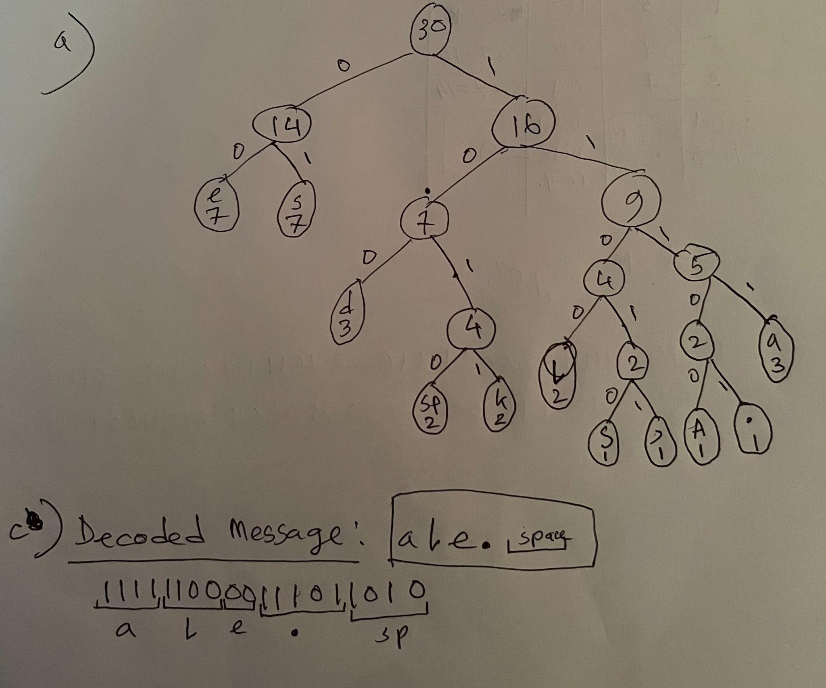 | 2
3. | Today Alice has learned how to find the Longest Common Subsequence (LCS) of two given strings. Now she wants to find the LCS of “axyb” and “axyxb”. After hours of hard work, she has made this LCS table, M.  empty a x y x b  empty 0 0 0 0 0 0  a 0 1 1 1 1 1  x 0 1 2 2 2 2  y 0 1 2 3 3 3  b 0 1 2 3 3 4
 | a.  CO1 | Explain what you understand by the value M[3][4] = 3.  M[3][4] denotes the LCS of “axy” and “axyx”, which is “axy”. | 2
 | b.  CO2 | Find out the LCS String from the table. Show the steps of your work.  Solution:  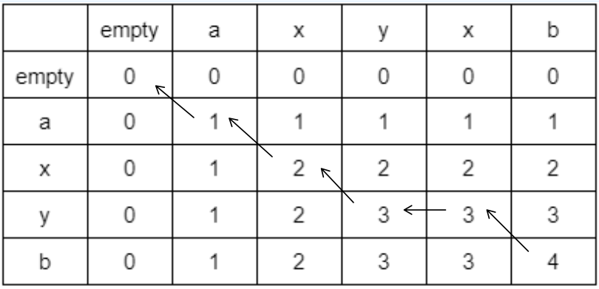  The LCS string is “axyb” | 3
 | c.  CO4 | Determine the maximum profit for the 0-1 Knapsack problem given in the following table using Dynamic Programming. Show the steps with a recursion tree or the memory matrix.  Knapsack Weight: 8 kg  Objects i ii iii iv  Weight (kg) 5 4 6 3  Profit ($) 9 8 20 9  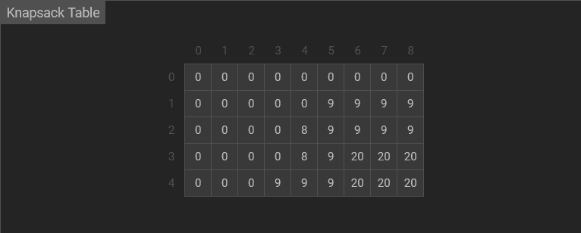 | 5

